The Board of Education of the Northridge Local School District met in Regular Session on Monday, August 16, 2021 at 6:30 PM, in the Northridge District Office Meeting Room in Johnstown, Ohio with the following individuals present: Mrs. Jayma Bammerlin, Mr. Rick Burkholder, Mr. Doug Hart, Mr. Chris Pokorny, Board Members; Mr. Scott Schmidt, Local Superintendent; Dr. Kristine Michael, Assistant Superintendent; Mr. Britt Lewis, Treasurer/CFO; Building Administrators and other interested citizens and employees.

The meeting was called to order at 6:32 P.M. by Mr. Doug Hart, Board President followed by the pledge of allegiance and roll call for attendance.

Roll Call: Mrs. Bammerlin, present; Mr. Burkholder, present; Mr. Pokorny, present; Mr. Schrock, arrived 7:03PM; Mr. Hart, present.

Mission and Viking Values Statements
Mission Statement: Empowering all students to reach their fullest potential

Viking Values: Trust, Leadership, Communication, Collaboration, Accountability, Integrity, Respect

See Something, Say Something

Approve Minutes

21-073 It was moved by Mr. Pokorny and seconded by Mr. Burkholder to approve the minutes of Regular Session Monday, June 21, 2021, Special Meeting Tuesday, June 29, 2021, Special Meeting July 7, 2021, Regular Session July 19, 2021 as submitted on August 13, 2021.

Roll Call: Mr. Pokorny, aye; Mr. Hart, aye; Mr. Burkholder, aye; Mrs. Bammerlin, aye.
The President declared the motion carried. 4-0.

Adoption of the Agenda

- Overview of Consent Agenda Items
- Changes to the Agenda
- Approval of the Agenda-as modified with Recommendation #14 being pulled for separate consideration as modified

21-074 It was moved by Mr. Pokorny and seconded by Mrs. Bammerlin to approve the agenda as modified.

Roll Call: Mr. Pokorny, aye; Mr. Hart, aye; Mr. Burkholder, aye; Mrs. Bammerlin, aye.
The President declared the motion carried. 4-0.

Scheduled Visitors:

- Modern Learning Facility Update- Owners Representative Mike Mendenhall, Mendenhall & Associates and Construction Contractor Clay Keith, Robertson Construction.

- Mr. Mendenhall completed walk through of the Elementary School as part of the punch list review with the Robertson team. Very pleased with follow through on the punch list and wrapping up this project.

Staff Comments Regarding Specific Agenda Items-None

Unscheduled Visitors (Maximum 30 minutes) Comments of Specific Agenda items
Mr. Hart explained the process for public comments.

Mrs. Vance spoke concerning School District facemask/facial covering and COVID protocol.

Discussion Items:

- Treasurer
- Finance Committee – update on the 20-year permanent improvement funds analysis.

- Superintendent
- Hartford Fair Report- Was a big success. Someone in the tent each night 5:00-7:00PM except storm nights.
- COVID Watch and Operations 2021-
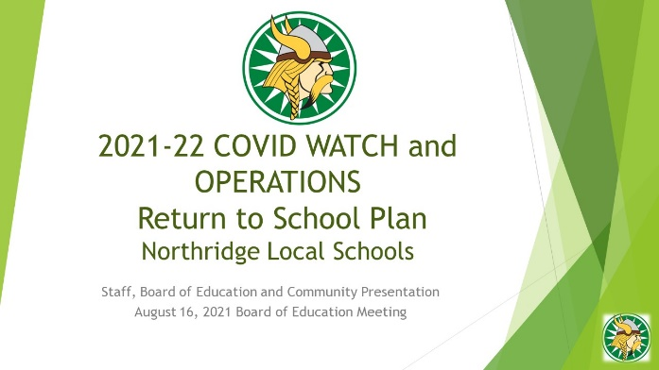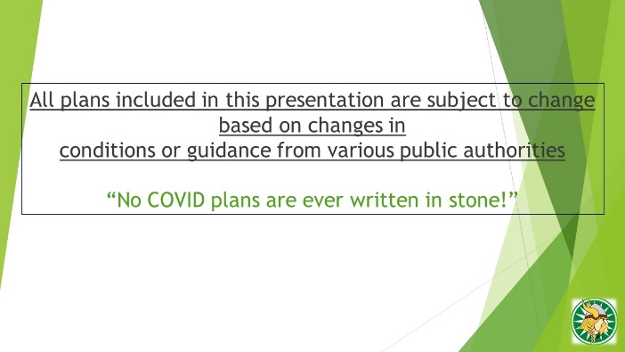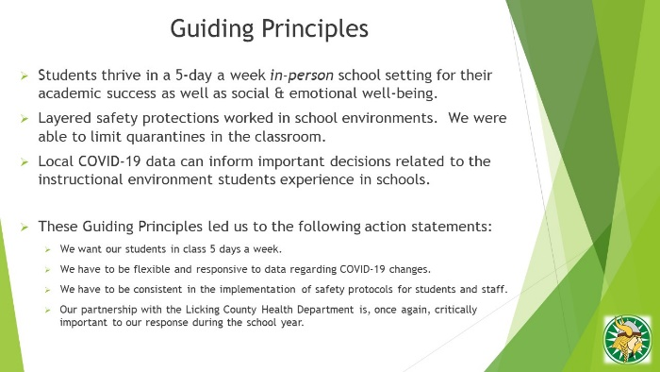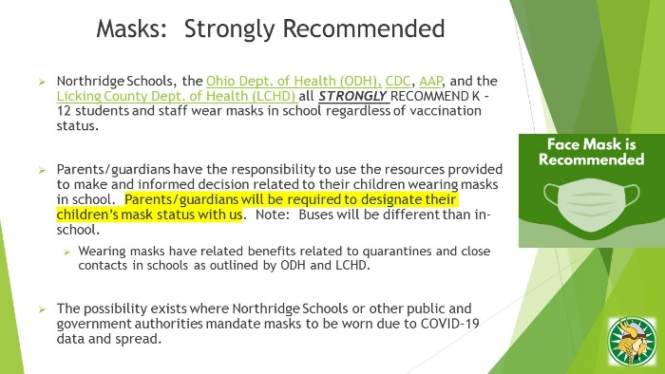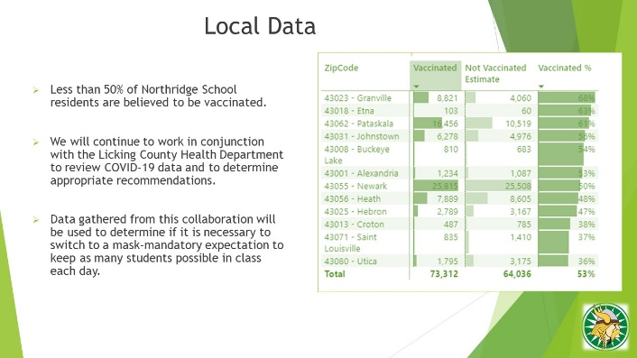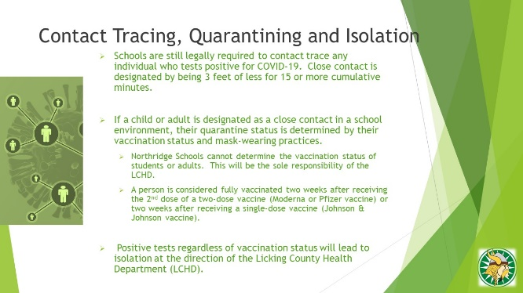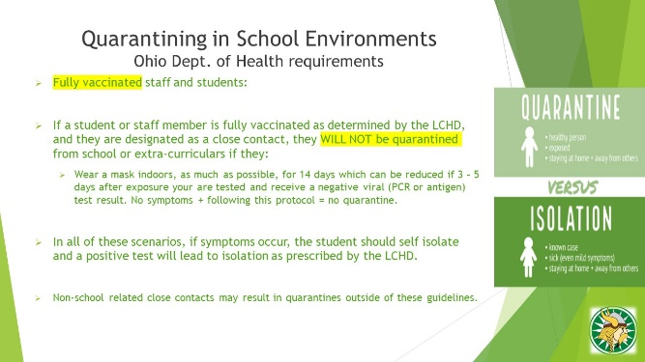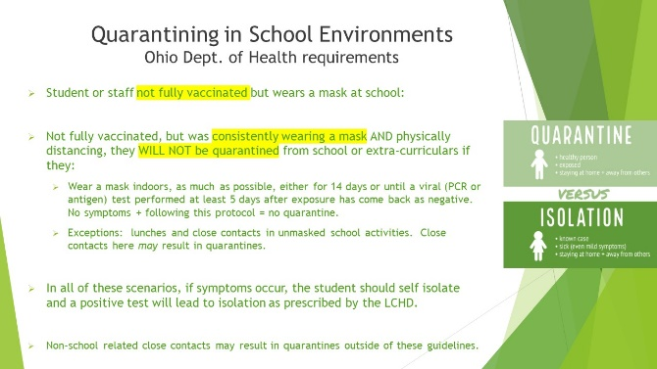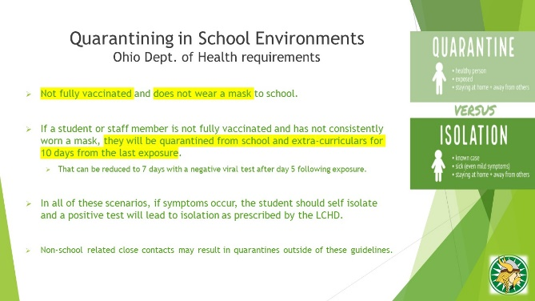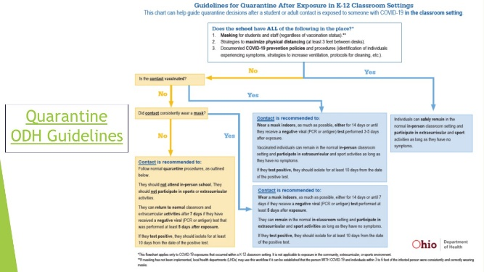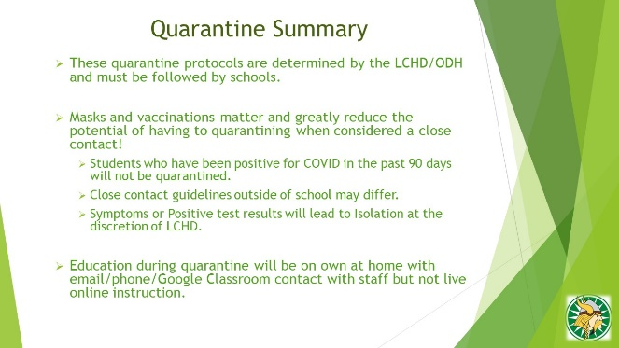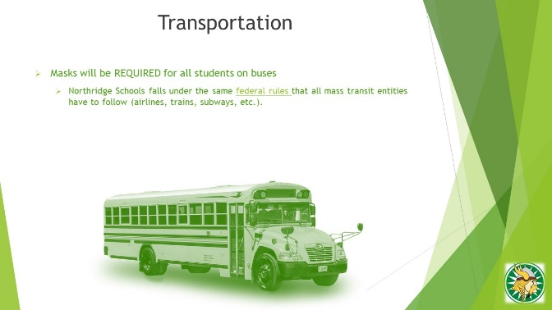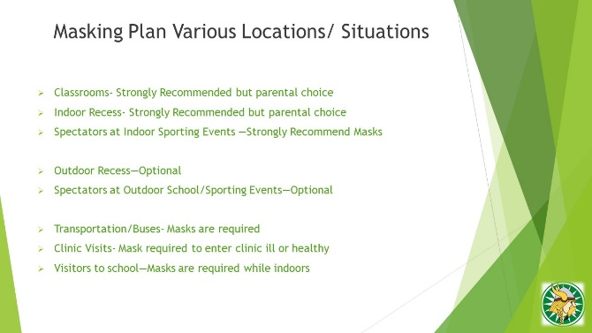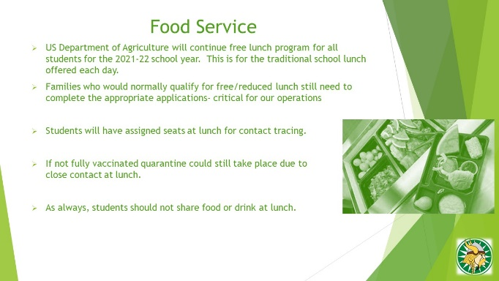
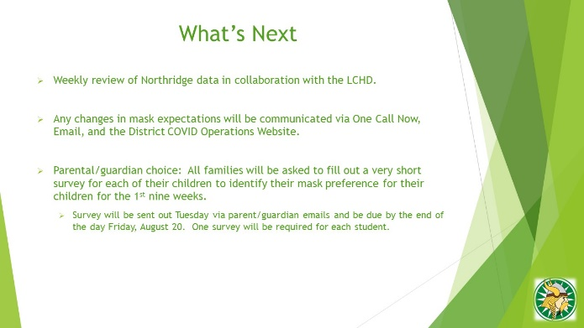

Consent Agenda

Treasurer’s Report and Recommendations

Recommendation # 1 - Approve Monthly Financial Reports
Recommendation to approve the Monthly Financial Reports as approved by Finance Committee as submitted on August 4, 2021.

Recommendation # 2 – Approve 2021-2022 Bus Routes
Recommendation to approve the Northridge Local Schools bus routes for the 2021-2022 school year as submitted in summary on August, 16 2021.

Superintendent’s Recommendations

Recommendation # 1 – Approve Resignations
Recommendation to approve the following resignations:
-Anne Patti – MS Cafeteria

Recommendation # 2 - Approve Certified Staff Voluntary Transfer
Recommendation to approve the following certified voluntary transfer beginning with school year 2021-2022:
-Suzanne Brungart from Grade 2 Teacher to K-3 Math Specialist Teacher
-Julia Liggett from Grade 6 Math to Grade 6 Science Teacher
-Nikki Ruiz from MS Title teacher to Grade 8 ELA Teacher
-Gretel Lloyd from 5th grade Social Studies to MS Title Teacher
-Kaylina Ruth from Grade 6 ELA to Grade 4 Math/ELA Teacher
-Ashley Carr from Grade 6 Intervention Specialist to Grade 7 Intervention Specialist
-Chelsey Chester from MS Cross Cat teacher to Grade 8 Intervention Specialist

Recommendation # 3 – Approve New Hire Certification Employment:
Recommendation to approve the following certificated contract(s) contingent upon favorable reports of the content of the BCI/FBI checks, Ohio Department of Education Certification and all other employment requirements for the 2021-2022 school year:

First Name | Last Name | Step | Cert. | Contract | Salary | Position
Olivia | Coon-Bitner | 1 | BA | 1 Year | $38,250.00 | GR6 Elective Teacher
Madeleine | Keller | 0 | BA150 | 1 Year | $38,250.00 | GR5 ELA Teacher
Recommendation # 4 – Approve Certified Salary Correction
Recommendation to approve salary column correction for Hayley Hummell, Teacher, from MA+15 Step 6 to MA Step 6 (previously approved June 21, 2021 regular meeting).

Recommendation # 5 – Approve Classified Staff Employment for the 2021-2022 School Year
Recommendation to approve the following on a one year limited classified contract commencing with the 2021-2022 school year pending favorable reports of the content of the BCI/FBI check and meeting all other employment requirements:
Name | Contract | Step | Rate of Pay | Position
Caudell, Nicole | 1 Yr. | 5 | $13.69/Hr. | HS Educational Aide
Chambers, Violet (Missy) | 1 Yr. | 10 | $15.11/Hr. | MS Educational Aide
Cooper, Heather | 1 Yr. | 8 | $14.53/Hr. | Elem. Educational Aide
Erwin, Karen | 1 Yr. | 10 | $15.11/Hr. | Elem. Educational Aide
Herald, Jamie | 1 Yr. | 1 | $15.42/Hr. | HS Custodian (Part-time)
Mattia, Katie | 1 Yr. | 7 | $14.24/Hr. | MS Educational Aide
McConnell, A Jean | 1 Yr. | 15 | $16.28/Hr. | HS Educational Aide
Mercurio, Anita | 1 Yr. | 12 | $15.57/Hr. | HS Educational Aide
Miller, Amber | 1 Yr. | 5 | $13.69/Hr. | Preschool Educational Aide
Miller, Mandy | 1 Yr. | 0 | $12.40/Hr. | Preschool – Elem. Ed Aide
Moore, Amanda | 1 Yr. | 3 | $13.16/Hr. | Elem. Educational Aide
Prime, Megan | 1 Yr. | 8 | $14.53/Hr. | Preschool Educational Aide
Redanty, Carol Ann | 1 Yr. | 9 | $14.82/Hr. | MS Educational Aide
Richey, Megan | 1 Yr. | 6 | $13.96/Hr. | MS Educational Aide
Spillman, Janelle | 1 Yr. | 5 | $13.69/Hr. | Elem. Educational Aide (Part-time)
Stocks, Tricia | 1 Yr. | 9 | $14.82/Hr. | Elem. Educational Aide
Stought, Jonda | 1 Yr. | 13 | $15.80/Hr. | Elem. Educational Aide
Thomas, Julia | 1 Yr. | 4 | $13.42/Hr. | Preschool – Elem. Educational Aide
Wilson, Ross | 1 Yr. | 4 | $13.42/Hr. | HS Educational Aide
Wittman, Jennifer | 1 Yr. | 5 | $13.69/Hr. | Elem. Educational Aide

Recommendation # 6 – Approve Classified Staff Position Movement
Recommendation to approve the following classified staff member position movement beginning for school year 2021-2022:
Name | Step | Rate of Pay | Position | (Previous Position)
King, Lynette | 12 | $16.29 per hour | Elem. Head Cook | Café Staff

Recommendation # 7 – Approve 2021-2022 Supplemental Contracts
Recommendation to approve the following 2021-2022 Supplemental Contracts contingent upon favorable reports of the content of the BCI/FBI checks, Ohio Department of Education certification and all other employment requirements:
First Name | Last Name | Position | Step | Rate of Pay
Jason | Aamodt | MS Assist. Football Coach | 0 | $2,528.00
Brian | Blume | MS Game Day Coordinator (Fall/Winter) | 1 | $3,499.00/Season
Bryan | Callahan | Assist. VR Football Coach | 1 | $3,499.00
Duane | Douglas | Assist. VR Volleyball Coach | 5 | $3,788.00
Steven | Durr | Assist. VR Volleyball Coach-JV | 6 | $3,864.00
Lee | Hatfield | MS Assist. Football Coach | 7 | $2,904.00
Ashley | Reed | MS Volleyball Coach-8th Grade | 8 | $3,385.00
Taylor | Rose | Assist. VR Volleyball Coach-Freshman | 3 | $3,641.00
John | Smith | HS Game Day Coordinator (Fall/Winter) | 7 | $3,941.00/Season
Claire | Sterling | MS Volleyball Coach-7th Grade | 0 | $2,889.00
Robert Brad | Wood | MS Combined Football Coach | 0 | $3,431.00

Recommendation # 8 – Approve Classified Substitutes for the 2021-2022 School Year
Recommendation to approve the following substitute personnel on an as-needed basis at the hourly rate determined by Board approved sub pay rates per position for the 2021-2022 school year pending favorable reports of the content of the BCI/FBI check and meeting all other employment requirements.
First Name | Last Name |  | First Name | Last Name
Melissa | Bailey |  | Deborah | Barrett
Stacy | Blackburn |  | Heather | Downing
Shawn | Elkins |  | Terry | Martin
Kelli | McClure |  | Deanna | Phares
Rebecca | Wengert |  | Logan | Willeke

Recommendation # 9 – Approve 2021-2022 Fund Raisers
Recommendation to approve the following 2021-2022 fund-raisers as submitted on August 13, 2021:

- Northridge FFA – Strawberry Sale
- Northridge FFA – Fruit Sale

Recommendation # 10 – Approve 2021-2022 Volunteers
Recommendation to approve the following as a volunteer for the 2021-2022 school year pending a favorable report on the content of the BCI and/or FBI check and meeting all other volunteer requirements. (A=Athletic Volunteer)
First Name | Last Name |  | First Name | Last Name
Daniel | Hatfield (A) |  | Keith | Stought (A)
Jeremy | Wheeler (A)

Recommendation # 11 – Approve Supplemental Salary Correction
Recommendation to approve supplemental salary correction for Anthony Keys, Head Varsity Volleyball Coach, previously board approved June 21, 2021, correction to paid experience to step 7 with corrected salary amount of $4,563.00.

Recommendation # 12 – Approve Purchase of Bobcat 5600 with attachments
Recommendation to approve purchase of a Bobcat 5600 with attachments, as submitted on August 13, 2021

Recommendation # 13 - Approve SRO contract with Licking County Sheriff’s Office
Recommendation to approve a 3-year contract with Licking County Sheriff’s Office to provide one full time School Resource officer per contract submitted August 13, 2021.

Recommendation # 15 - Approve Waived Academic Fees
Recommendation to approve one-year continuation of no academic school fees for grades
K-12 for the 2021-2022 school year and the Superintendent and Treasurer/CFO to jointly determine the cost for any specific course academic fees if applicable.

Recommendation # 16 - Approve Waived Student Activity Fees
Recommendation to approve one-year continuation of no Student Activity Fees for grades
K-12 for the 2021-2022 school year and the Superintendent and Treasurer/CFO to jointly determine the cost for any activity specific appropriate activity fee necessary if any.

Recommendation # 17 – Approve 2021-2022 Student Handbooks
Recommendation to approve the Preschool, Elementary School, and High School/ Middle School 2021-2022 handbooks as submitted on August 13, 2021.

Recommendation # 18 – Approve 2021-2022 Athletic Handbook
Recommendation to approve High School and Middle School 2021-2022 Athletic Handbook as submitted on August 13, 2021.

Recommendation # 19 – Approve FY22 ESCCO Service Agreement
Recommendation to approve the FY22 Educational Service Center of Central Ohio District Service Plan as submitted on August 13, 2021.

Recommendation # 20 - Approve Additional Days/Hours for Certificated Staff
Recommendation to approve the following certified staff members for Kindergarten screening during the month of August 2021, not to exceed additional 16 hours, for the SY2021-2022:

Katy Beach-Black, Deb Peterman, and Ashley Ramsey

21-075 It was moved by Mr. Pokorny and seconded by Mrs. Bammerlin to approve the above consent recommendations.

Roll Call: Mr. Schrock, aye; Mr. Pokorny, aye; Mr. Hart, aye; Mr. Burkholder, aye; Mrs. Bammerlin, aye.
The President declared the motion carried. 5-0.

Items Removed from Consent Agenda for Separate Consideration

Recommendation # 14 - Approve Substitute Teacher Rate of Pay
Recommendation to approve substitute teacher rate of pay of $105.00 a day effective with the start of the 2021-22 school year.

21-076 It was moved by Mrs. Bammerlin and seconded by Mr. Burkholder to approve the above removed recommendation for separate consideration.

Roll Call: Mr. Schrock, aye; Mr. Pokorny, abstain; Mr. Hart, aye; Mr. Burkholder, aye; Mrs. Bammerlin, aye.
The President declared the motion carried. 4-0.

Separate Consideration Items

Recommendation # 1 – Approve Construction Change Orders
Recommendation to approve the following Site Improvement construction change order.

- Pending Change order to supply security planters at the elementary school, total cost not to exceed $4,000

21-077 It was moved by Mrs. Bammerlin and seconded by Mr. Pokorny to approve the above separate recommendation.

Roll Call: Mr. Schrock, aye; Mr. Pokorny, aye; Mr. Hart, aye; Mr. Burkholder, aye; Mrs. Bammerlin, aye.
The President declared the motion carried. 5-0.

Recommendation # 2 – Approve Online Ticketing Agreement
Recommendation to approve agreement with Hometown Digital Ticketing and Event Management to provide software for online ticketing to athletic events as submitted August 13, 2021.

Mr. Hart stated we need to accommodate all who want to enter the games regardless of their ability to use this online option.

Mr. Schmidt stated that we will still accept cash at the gate on game day.

Mr. Hart recommended to amend the motion to make the approval subject to finding a way to accommodate people that are otherwise unable to deal with the means this program requires to gain admission.

21-078 It was moved by Mr. Hart and seconded by Mr. Pokorny to amend the above separate recommendation as stated above. The president declared the motion passed by unanimous voice vote.

21-079 It was moved by Mr. Pokorny and seconded by Mrs. Bammerlin to approve the above separate recommendation as amended.

Roll Call: Mr. Schrock, aye; Mr. Pokorny, aye; Mr. Hart, aye; Mr. Burkholder, aye; Mrs. Bammerlin, aye.
The President declared the motion carried. 5-0.

Board Recommendation

Board Recommendation # 1 – Approve Superintendent’s Performance Incentive Payment

Recommendation to approve performance incentive payment of 5 percent for Mr. Scott Schmidt, for meeting yearly goals as described in section 4(c) of contract issued Feb. 18, 2020

Mr. Hart stated that Mr. Schmidt’s performance this year has been absolutely outstanding under the COVID circumstances. Your leadership has been outstanding working with the Licking County Health Department and Licking County Superintendents group.

Mr. Pokorny stated that it has been an extremely challenging year and that Mr. Schmidt rose to the challenge and commended him for good communication both to the District and the Board.

Mr. Burkholder stated he really appreciates Mr. Schmidt being easy to talk to and easy to understand, and I think that is really great.

21-080 It was moved by Mr. Hart and seconded by Mr. Pokorny to approve the above recommendation.

Roll Call: Mr. Schrock, aye; Mr. Pokorny, aye; Mr. Hart, aye; Mr. Burkholder, aye; Mrs. Bammerlin, aye.
The President declared the motion carried. 5-0.

Board Recommendation # 2 – Approve Treasurer’s Performance Incentive Payment
Recommendation to approve performance incentive payment of 5 percent for Mr. Britt Lewis, for meeting yearly goals as described in section 4(d) of contract issued April 18, 2017.

Mr. Hart stated that Mr. Lewis faced similar challenges in terms of dealing with ESSER funding and other funding cuts from the Governor. And applauding him for managing to navigate through those issues and still pull together another clean audit. The clean audits never get old, but I think that less than 10% of school districts in the State achieve that once, and you have done it 8 times in a row. So, 8 in a row and built a building is outstanding.

Mr. Pokorny stated as a former logistician, I can appreciate what you have to do as a budget manager, resource manager of everything, and you have a small staff that make a huge impact on our School District. A lot of people do not realize how much impact that your office and the people who work under your purview, the accounting, food service, custodial, maintenance and transportation staff. They are not large numbers, but they are all part of making a successful school district run and I appreciate your efforts and their efforts as well. That has led to your success. Thank you to you and the people who work under your supervision.

Mr. Schrock stated thank you on behalf of all the taxpayers and School District, I think you have done a great job overseeing their tax dollars and you work hard to help support this School District.

21-081 It was moved by Mr. Hart and seconded by Mrs. Bammerlin to approve the above recommendation.

Roll Call: Mr. Schrock, aye; Mr. Pokorny, aye; Mr. Hart, aye; Mr. Burkholder, aye; Mrs. Bammerlin, aye.
The President declared the motion carried. 5-0.

Board Recommendation # 3 Approve OSBA 2021 Delegate
It was moved by__________ and seconded by _____________ to appoint _______________as Delegate to the OSDA Business Meeting, with _________________as alternate. This meeting is scheduled for Monday, November 8, 2021, 8am at the Union Station Ballroom.

21-082 It was moved by Mrs. Bammerlin and seconded by Mr. Pokorny to Table Board Recommendation #3. The president declared the motion passed by unanimous voice vote.

Business Initiated by Members of the Board - None

Unscheduled Visitors (Maximum 30 minutes, including Item IX

Brook Burcham spoke concerning School District facemask/facial covering and COVID protocol and critical race theory.

Loren Keith spoke concerning School District facemask/facial covering and COVID protocol.

Mrs. Vance spoke concerning critical race theory.

Announcements

New Teacher Orientation August 17th-18th
Convocation Monday August 23rd at 8am
1st day of school Wednesday, August 25, 2021

Reaffirm Time and Place of Next Board of Education Meeting(s):

Regular Date: Monday, September 20, 2021 Time: 6:30PM Location: District Office Mtg Room

Reaffirm Time and Place of Next Committee Meetings:

Academic/Excellence Date: Wednesday, August 25, 2021 Time: 6:30PM Location: District Office Mtg Room
Finance Date: Wednesday, September 8, 2021 Time: 6:00PM Location: District Office

Executive Session Did not enter

Adjourn Meeting

21-083 It was moved by Mr. Schrock and seconded by Mr. Pokorny to adjourn the meeting at 8:52 PM. The president declared the motion carried by unanimous voice vote.

_____________________________________________ Board President

__________________________________________________ Treasurer

In addition to the minutes an auditory recording is recorded during each Board meeting. The recording is available to the public during regular working hours of the Northridge Local Schools District Office.

